 | State Police Cyber Intelligence Unit  Intelligence Summary  Prepared for: Senior Law Enforcement Executive  INTSUM Number: 001  Emerging cyber-enabled threat activity linked to “Southern Requiem”

Report Date | 13 – AUG-2026
Report Time | 17:00
Produced by
Cleared by
Period Covered | From 13-AUG-2026, 14:00 – 13-AUG-2026, 17:00
Next INTSUM Due | 13-AUG-2026, 21:00

Key Finding
Should include:
- The 3 to 5 most significant findings from the intelligence assessment.
- Analytical judgements, not raw information.
- Findings that are relevant to decision-makers.
- Emerging risks, trends, opportunities, or threats.
- Confidence levels where appropriate.

Background and Intent

- What is happening?
- What is the emerging threat?
- What is the likely intent and capability?
- Who may be involved?
- Why the intelligence product has been prepared.
- The intelligence requirement, objective, or question being addressed.

Assessment

- How credible is the threat?
- How imminent is the threat?
- What are the likely risks to law enforcement operations, public confidence, and staff safety?

Opportunities/Key Considerations

- What should executives do in the next 24–72 hours?
- What immediate actions should senior executives consider?
- Three recommended actions for the next 24 hours

Intelligence Cell Next Steps

- What intelligence gaps remain?

Prepared By

Appendix A:
When reporting intelligence, Words of Estimative Probability (WEPs) are used to succinctly convey the level of certainty the Intel Practitioner has about their findings. It is important for the intelligence practitioner to clearly identify their confidence in a finding or prediction, without this context, the analysis or prediction can be misleading. Intelligence assessments are often based on incomplete or fragmented information available at the time of writing and are not necessarily fact or proof. If the sentence is factual, then a WEP should not be included.
WEPs are a statement of likelihood and represent a variance of up to +/-10%
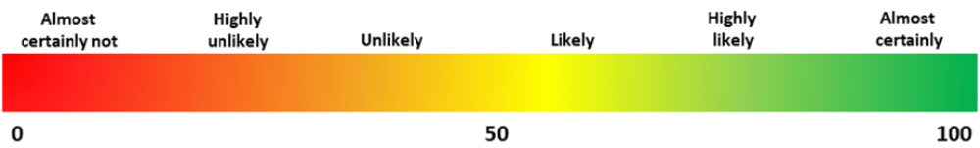
Figure 11: Words of estimative probability include variance of up to +/-10%

